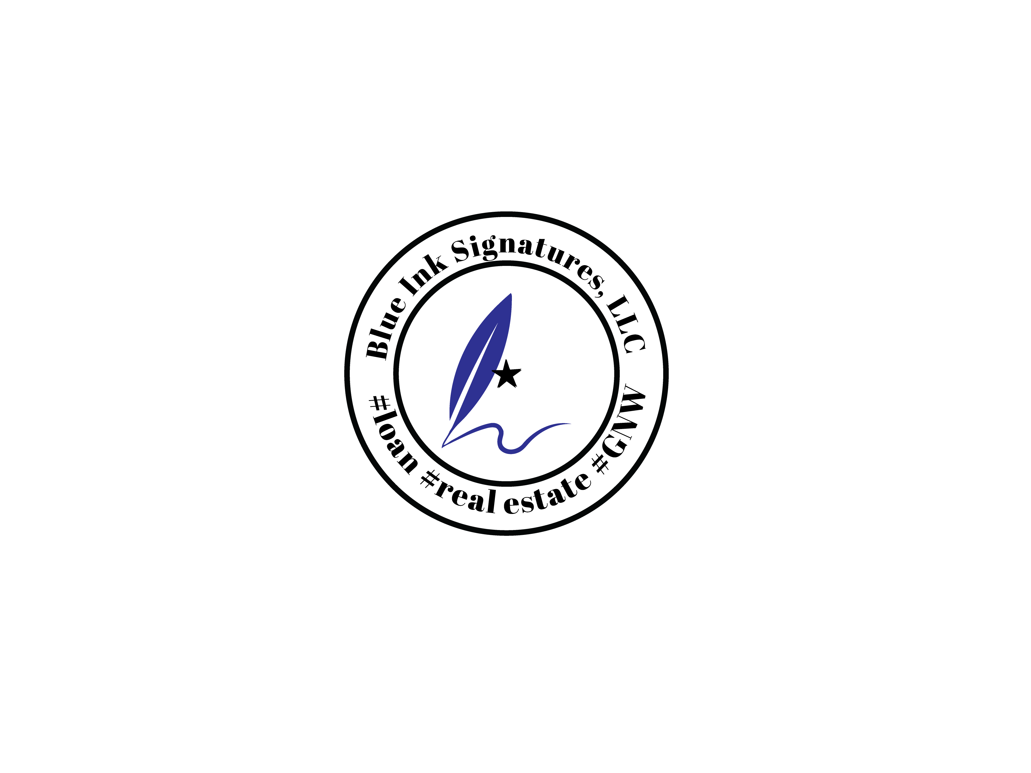 | DUNS#: 117780821  CAGE#: 90AD8  NAICS CODES (commonly supported):  541199, 541120, 812990, 423490
Signing services such as Bancserv, Amrock, Loan-closers, Express Notary and Title 365/Xome trust my company to handle and execute the final process of Loan Documents for the clients because we ensure first and foremost identity has been confirmed and verified and that all documents are initialed, signed and dated by borrowers are said to be true and correct. I also provide mobile services and offer coaching and mentoring to new Loan Signing Agents.
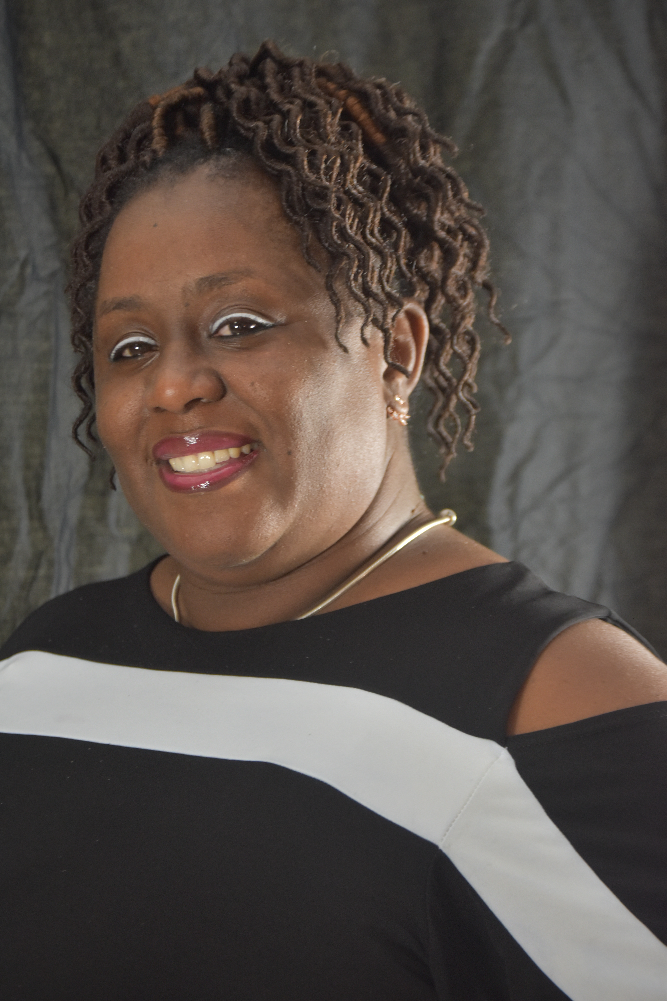  CONTACT:  Shantrell Simmons, Owner  Blue Ink Signatures, LLC  dba Trell’s Notary Service  Mobile Notary  Pompano Beach, FL 33069  Cell: 954-803-6879 OFFICE: 954-247-8145  www.trellsnotaryservices.com  2020notaryservices@gmail.com |  | WHO WE ARE  - State of Florida Commission Notary since 2004  - Certified Loan Signing Agent since 2019  - We are licensed, insured and bonded notary public service who complies to Florida standards  - We believe in the importance of diligence in professional care and conduct  - We are a fully mobile business  WHAT WE DO  - VIN verifications  - Power of Attorney  - Wills  - Mortgage / Loan Documents  - Business Verifications  - Coaching / Mentoring  - Inventory of safe-deposit box


